NAMA : AKHDAN IJLAL
NIM : 2414000011

SOAL.

1. Perhatikan tiket online berikut :
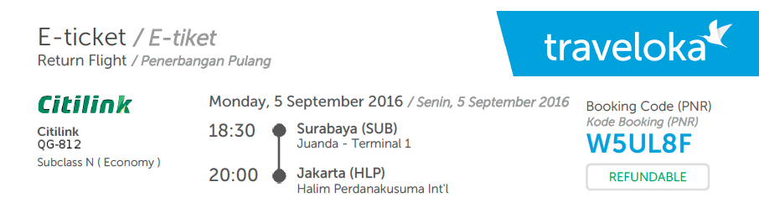

2. Perhatikan bukti transaksi berikut :
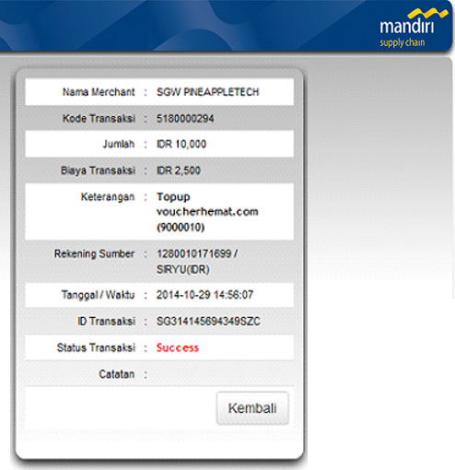

NORMALISASI DARI KEDUA SOAL

1. Tiket Pesawat
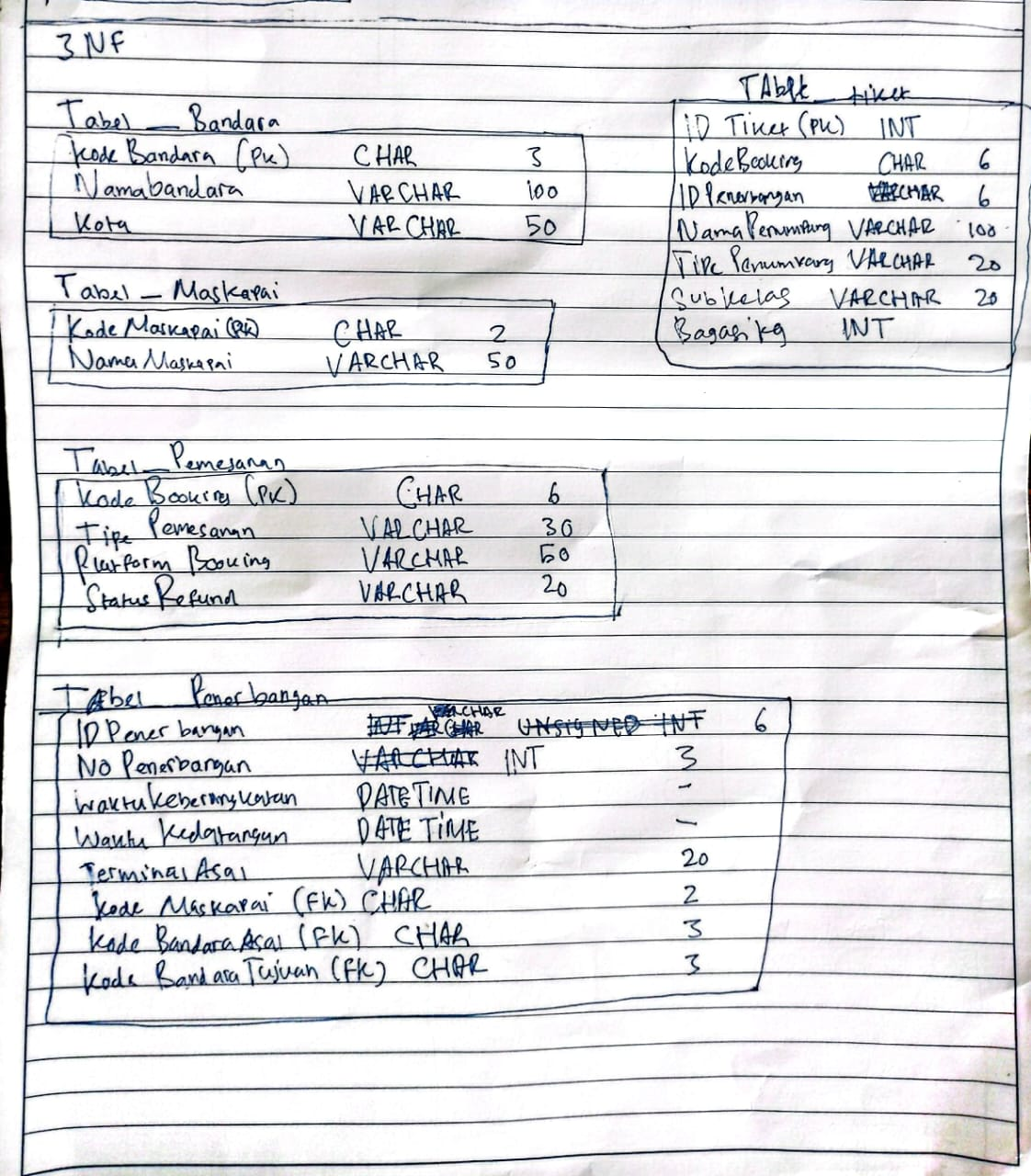

2. Bukti Transaksi
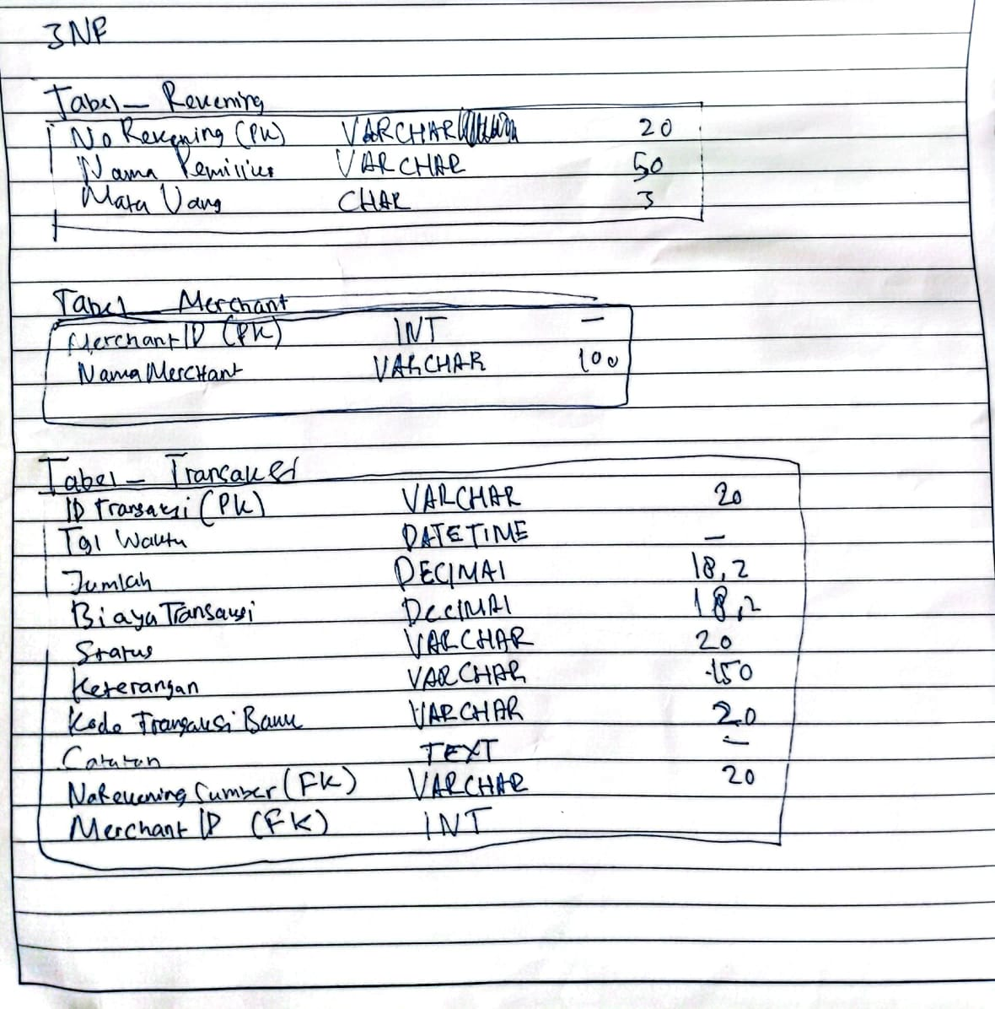

TIKET PENERBANGAN

Setting environment for using XAMPP for Windows.
pc@DESKTOP-3VRLMNO c:\xampp
# mysql -u root -p
Enter password:
Welcome to the MariaDB monitor. Commands end with ; or \g.
Your MariaDB connection id is 22
Server version: 10.4.32-MariaDB mariadb.org binary distribution

Copyright (c) 2000, 2018, Oracle, MariaDB Corporation Ab and others.

Type 'help;' or '\h' for help. Type '\c' to clear the current input statement.

MariaDB [(none)]> CREATE DATABASE penerbangan;
Query OK, 1 row affected (0.002 sec)

MariaDB [(none)]> SHOW DATABASE;
ERROR 1064 (42000): You have an error in your SQL syntax; check the manual that corresponds to your MariaDB server version for the right syntax to use near 'DATABASE' at line 1
MariaDB [(none)]> SHOW DATABASES
-> USE penerbangan;
ERROR 1064 (42000): You have an error in your SQL syntax; check the manual that corresponds to your MariaDB server version for the right syntax to use near 'USE penerbangan' at line 2
MariaDB [(none)]> USE penerbangan;
Database changed
MariaDB [penerbangan]> SHOW DATABASES
-> USE penerbangan;
ERROR 1064 (42000): You have an error in your SQL syntax; check the manual that corresponds to your MariaDB server version for the right syntax to use near 'USE penerbangan' at line 2
MariaDB [penerbangan]> SHOW DATABASES;
+--------------------+
| Database |
+--------------------+
| information_schema |
| mysql |
| penerbangan |
| performance_schema |
| phpmyadmin |
| test |
+--------------------+
6 rows in set (0.002 sec)

MariaDB [penerbangan]> USE penerbangan;
Database changed
MariaDB [penerbangan]> CREATE TABLE bandara(
-> kode_bandara CHAR(3) PRIMARY KEY,
-> nama_bandara VARCHAR(100) NOT NULL,
-> kota VARCHAR(50) NOT NULL
-> );
Query OK, 0 rows affected (0.023 sec)

MariaDB [penerbangan]> SHOW TABLES
-> DESCRIBE bandara
-> ;
ERROR 1064 (42000): You have an error in your SQL syntax; check the manual that corresponds to your MariaDB server version for the right syntax to use near 'DESCRIBE bandara' at line 2
MariaDB [penerbangan]> DESCRIBE bandara;
+--------------+--------------+------+-----+---------+-------+
| Field | Type | Null | Key | Default | Extra |
+--------------+--------------+------+-----+---------+-------+
| kode_bandara | char(3) | NO | PRI | NULL | |
| nama_bandara | varchar(100) | NO | | NULL | |
| kota | varchar(50) | NO | | NULL | |
+--------------+--------------+------+-----+---------+-------+
3 rows in set (0.033 sec)

MariaDB [penerbangan]> CREATE TABLE maskapai(
-> kodeMaskapai CHAR(3) PRIMARY KEY,
-> namaMaskapai VARCHAR(50) NOT NULL
-> );
Query OK, 0 rows affected (0.022 sec)

MariaDB [penerbangan]> SHOW TABLES
-> DESCRIBE maskapai
-> ;
ERROR 1064 (42000): You have an error in your SQL syntax; check the manual that corresponds to your MariaDB server version for the right syntax to use near 'DESCRIBE maskapai' at line 2
MariaDB [penerbangan]> DESCRIBE maskapai;
+--------------+-------------+------+-----+---------+-------+
| Field | Type | Null | Key | Default | Extra |
+--------------+-------------+------+-----+---------+-------+
| kodeMaskapai | char(3) | NO | PRI | NULL | |
| namaMaskapai | varchar(50) | NO | | NULL | |
+--------------+-------------+------+-----+---------+-------+
2 rows in set (0.033 sec)

MariaDB [penerbangan]> CREATE TABLE pemesanan(
-> kodeBooking CHAR(6) PRIMARY KEY,
-> tipePemesanan VARCHAR(30) NOT NULL,
-> platformBooking VARCHAR(50) NOT NULL,
-> statusRefund VARCHAR(20) NOT NULL
-> );
Query OK, 0 rows affected (0.024 sec)

MariaDB [penerbangan]> SHOW TABLES;
+-----------------------+
| Tables_in_penerbangan |
+-----------------------+
| bandara |
| maskapai |
| pemesanan |
+-----------------------+
3 rows in set (0.001 sec)

MariaDB [penerbangan]> CREATE TABLE penerbangan(
-> IDPenerbangan CHAR(6) PRIMARY KEY,
-> NOPenerbangan INT(3) NOT NULL,
-> waktuPenerbangan DATETIME NOT NULL,
-> waktuKedatangan DATETIME NOT NULL,
-> terminalAsal VARCHAR(20) NOT NULL,
-> );
ERROR 1064 (42000): You have an error in your SQL syntax; check the manual that corresponds to your MariaDB server version for the right syntax to use near ')' at line 7
MariaDB [penerbangan]> CREATE TABLE penerbangan(
-> -> IDPenerbangan CHAR(6) PRIMARY KEY,
-> -> NOPenerbangan INT(3) NOT NULL,
-> -> waktuPenerbangan DATETIME NOT NULL,
-> -> waktuKedatangan DATETIME NOT NULL,
-> -> terminalAsal VARCHAR(20) NOT NULL,
->
-> );
ERROR 1064 (42000): You have an error in your SQL syntax; check the manual that corresponds to your MariaDB server version for the right syntax to use near '-> IDPenerbangan CHAR(6) PRIMARY KEY,
-> NOPenerbangan INT(3) NOT NULL,
...' at line 2
MariaDB [penerbangan]> CREATE TABLE penerbangan(
-> -> IDPenerbangan CHAR(6) PRIMARY KEY,
-> -> NOPenerbangan INT(3) NOT NULL,
-> -> waktuPenerbangan DATETIME NOT NULL,
-> -> waktuKedatangan DATETIME NOT NULL,
-> -> terminalAsal VARCHAR(20) NOT NULL
-> -> );
ERROR 1064 (42000): You have an error in your SQL syntax; check the manual that corresponds to your MariaDB server version for the right syntax to use near '-> IDPenerbangan CHAR(6) PRIMARY KEY,
-> NOPenerbangan INT(3) NOT NULL,
...' at line 2
MariaDB [penerbangan]> CREATE TABLE penerbangan(
-> IDPenerbangan CHAR(6) PRIMARY KEY,
-> NOPenerbangan INT(3) NOT NULL,
-> waktuPenerbangan DATETIME NOT NULL,
-> waktuKedatangan DATETIME NOT NULL,
-> terminalAsal VARCHAR(20) NOT NULL
-> );
Query OK, 0 rows affected (0.016 sec)

MariaDB [penerbangan]> CREATE TABLE tiket(
-> IDTiket INT PRIMARY KEY,
-> kodeBooking CHAR(6) NOT NULL,
->
-> );
ERROR 1064 (42000): You have an error in your SQL syntax; check the manual that corresponds to your MariaDB server version for the right syntax to use near ')' at line 5
MariaDB [penerbangan]> CREATE TABLE tiket(
-> IDTiket INT PRIMARY KEY,
-> namaPenumpang VARCHAR(100) NOT NULL,
-> tipePenumpang VARCHAR(20),
-> subkelas VARCHAR(20) NOT NULL,
-> bagasiKG INT
-> );
Query OK, 0 rows affected (0.022 sec)

MariaDB [penerbangan]> SHOW TABLES
-> );
ERROR 1064 (42000): You have an error in your SQL syntax; check the manual that corresponds to your MariaDB server version for the right syntax to use near ')' at line 2
MariaDB [penerbangan]> SHOW TABLES);
ERROR 1064 (42000): You have an error in your SQL syntax; check the manual that corresponds to your MariaDB server version for the right syntax to use near ')' at line 1
MariaDB [penerbangan]> SHOW TABLES;
+-----------------------+
| Tables_in_penerbangan |
+-----------------------+
| bandara |
| maskapai |
| pemesanan |
| penerbangan |
| tiket |
+-----------------------+
5 rows in set (0.001 sec)

MariaDB [penerbangan]> DESCRIBE tiket;
+---------------+--------------+------+-----+---------+-------+
| Field | Type | Null | Key | Default | Extra |
+---------------+--------------+------+-----+---------+-------+
| IDTiket | int(11) | NO | PRI | NULL | |
| namaPenumpang | varchar(100) | NO | | NULL | |
| tipePenumpang | varchar(20) | YES | | NULL | |
| subkelas | varchar(20) | NO | | NULL | |
| bagasiKG | int(11) | YES | | NULL | |
+---------------+--------------+------+-----+---------+-------+
5 rows in set (0.034 sec)

MariaDB [penerbangan]> INSERT INTO bandara;
ERROR 1064 (42000): You have an error in your SQL syntax; check the manual that corresponds to your MariaDB server version for the right syntax to use near '' at line 1
MariaDB [penerbangan]> INSERT INTO bandara;
ERROR 1064 (42000): You have an error in your SQL syntax; check the manual that corresponds to your MariaDB server version for the right syntax to use near '' at line 1
MariaDB [penerbangan]> ALTER TABLE penerbangan
-> ADD fk_penerbangan_maskapai
-> FOREIGN KEY (kodeMaskapai)
-> REFERENCES maskapai (kodeMaskapai)
-> ON DELETE RESTRICT
-> ON UPDATE CASCADE;
ERROR 1064 (42000): You have an error in your SQL syntax; check the manual that corresponds to your MariaDB server version for the right syntax to use near 'FOREIGN KEY (kodeMaskapai)
REFERENCES maskapai (kodeMaskapai)
ON DELETE RESTR...' at line 3
MariaDB [penerbangan]> ALTER TABLE penerbangan
-> ADD COLUMN kodeMaskapai CHAR(3);
Query OK, 0 rows affected (0.011 sec)
Records: 0 Duplicates: 0 Warnings: 0

MariaDB [penerbangan]> ALTER TABLE penerbangan
-> ADD fk_penerbangan_maskapai
-> FOREIGN KEY (kodeMaskapai)
-> REFERENCES maskapai (kodeMaskapai)
-> ON DELETE RESTRICT
-> ON UPDATE CASCADE;
ERROR 1064 (42000): You have an error in your SQL syntax; check the manual that corresponds to your MariaDB server version for the right syntax to use near 'FOREIGN KEY (kodeMaskapai)
REFERENCES maskapai (kodeMaskapai)
ON DELETE RESTR...' at line 3
MariaDB [penerbangan]> SHOW TABLES
-> ;
+-----------------------+
| Tables_in_penerbangan |
+-----------------------+
| bandara |
| maskapai |
| pemesanan |
| penerbangan |
| tiket |
+-----------------------+
5 rows in set (0.001 sec)

MariaDB [penerbangan]> DICRIBE masakapai
-> ;
ERROR 1064 (42000): You have an error in your SQL syntax; check the manual that corresponds to your MariaDB server version for the right syntax to use near 'DICRIBE masakapai' at line 1
MariaDB [penerbangan]> DESCRIBE maskapai;
+--------------+-------------+------+-----+---------+-------+
| Field | Type | Null | Key | Default | Extra |
+--------------+-------------+------+-----+---------+-------+
| kodeMaskapai | char(3) | NO | PRI | NULL | |
| namaMaskapai | varchar(50) | NO | | NULL | |
+--------------+-------------+------+-----+---------+-------+
2 rows in set (0.036 sec)

MariaDB [penerbangan]> ALTER TABLE penerbangan
-> FOREIGN KEY (kodeMaskapai)
->
-> ;
ERROR 1064 (42000): You have an error in your SQL syntax; check the manual that corresponds to your MariaDB server version for the right syntax to use near 'FOREIGN KEY (kodeMaskapai)' at line 2
MariaDB [penerbangan]> ALTER TABLE penerbangan
-> ADD CONSTRAINT fk_penerbangan_maskapai
-> FOREIGN KEY (kodeMaskapai)
-> REFERENCES maskapai (kodeMaskapai)
-> ON DELETE RESTRICT
-> ON UPDATE CASCADE;
Query OK, 0 rows affected (0.082 sec)
Records: 0 Duplicates: 0 Warnings: 0

MariaDB [penerbangan]> ALTER TABLE penerbangan
-> ;
Query OK, 0 rows affected (0.002 sec)
Records: 0 Duplicates: 0 Warnings: 0

MariaDB [penerbangan]> SHOW TABLES;
+-----------------------+
| Tables_in_penerbangan |
+-----------------------+
| bandara |
| maskapai |
| pemesanan |
| penerbangan |
| tiket |
+-----------------------+
5 rows in set (0.001 sec)

MariaDB [penerbangan]> DESCRIBE bandara;
+--------------+--------------+------+-----+---------+-------+
| Field | Type | Null | Key | Default | Extra |
+--------------+--------------+------+-----+---------+-------+
| kode_bandara | char(3) | NO | PRI | NULL | |
| nama_bandara | varchar(100) | NO | | NULL | |
| kota | varchar(50) | NO | | NULL | |
+--------------+--------------+------+-----+---------+-------+
3 rows in set (0.035 sec)

MariaDB [penerbangan]> INSERT TO bandara(
-> kode_bandara,
-> nama_bandara,
-> kota,
-> ;
ERROR 1064 (42000): You have an error in your SQL syntax; check the manual that corresponds to your MariaDB server version for the right syntax to use near 'TO bandara(
kode_bandara,
nama_bandara,
kota,' at line 1
MariaDB [penerbangan]> INSERT TO bandara(
-> kode_bandara,
-> nama_bandara,
-> kota
-> )
-> VALUES(
-> 'SUB',
-> 'Juanda - Terminal 1',
-> 'Surabaya'
-> );
ERROR 1064 (42000): You have an error in your SQL syntax; check the manual that corresponds to your MariaDB server version for the right syntax to use near 'TO bandara(
kode_bandara,
nama_bandara,
kota
)
VALUES(
'SUB',
'Juanda - Termi...' at line 1
MariaDB [penerbangan]> INSERT INTO bandara(
-> kode_bandara,
-> nama_bandara,
-> kota
-> )
-> VALUES(
-> 'SUB',
-> 'Juanda - Terminal 1',
-> 'Surabaya'
-> );
Query OK, 1 row affected (0.013 sec)

MariaDB [penerbangan]> SELECT * FROM maskapai;
Empty set (0.001 sec)

MariaDB [penerbangan]> SELECT * FROM maskapai;
Empty set (0.000 sec)

MariaDB [penerbangan]> SELECT * FROM maskapai;
Empty set (0.001 sec)

MariaDB [penerbangan]> SELECT * FROM bandara;
+--------------+---------------------+----------+
| kode_bandara | nama_bandara | kota |
+--------------+---------------------+----------+
| SUB | Juanda - Terminal 1 | Surabaya |
+--------------+---------------------+----------+
1 row in set (0.001 sec)

MariaDB [penerbangan]> INSERT INTO maskapai(
-> ;
ERROR 1064 (42000): You have an error in your SQL syntax; check the manual that corresponds to your MariaDB server version for the right syntax to use near '' at line 1
MariaDB [penerbangan]> DESCRIBE maskapai;
+--------------+-------------+------+-----+---------+-------+
| Field | Type | Null | Key | Default | Extra |
+--------------+-------------+------+-----+---------+-------+
| kodeMaskapai | char(3) | NO | PRI | NULL | |
| namaMaskapai | varchar(50) | NO | | NULL | |
+--------------+-------------+------+-----+---------+-------+
2 rows in set (0.038 sec)

MariaDB [penerbangan]> INSERT INTO maskapai
-> (
-> kodeMaskapai,
-> namaMaskapai
-> )
-> VALUES(
-> 'QG',
-> 'citilink'
-> );
Query OK, 1 row affected (0.003 sec)

MariaDB [penerbangan]> DESCRIBE TABLES pemesanan
-> ;
ERROR 1146 (42S02): Table 'penerbangan.tables' doesn't exist
MariaDB [penerbangan]> DESCRIBE pemesanan;
+-----------------+-------------+------+-----+---------+-------+
| Field | Type | Null | Key | Default | Extra |
+-----------------+-------------+------+-----+---------+-------+
| kodeBooking | char(6) | NO | PRI | NULL | |
| tipePemesanan | varchar(30) | NO | | NULL | |
| platformBooking | varchar(50) | NO | | NULL | |
| statusRefund | varchar(20) | NO | | NULL | |
+-----------------+-------------+------+-----+---------+-------+
4 rows in set (0.033 sec)

MariaDB [penerbangan]> INSERT INTO pemesanan(
-> kodeBooking,
-> tipePemesanan,
-> platformBooking,
-> statusRefund
-> )
-> VALUES(
-> 'W5UL8F',
-> 'Dewasa',
-> 'Traveloka',
-> 'None'
-> );
Query OK, 1 row affected (0.012 sec)

MariaDB [penerbangan]> DESCRIBE penerbangan;
+------------------+-------------+------+-----+---------+-------+
| Field | Type | Null | Key | Default | Extra |
+------------------+-------------+------+-----+---------+-------+
| IDPenerbangan | char(6) | NO | PRI | NULL | |
| NOPenerbangan | int(3) | NO | | NULL | |
| waktuPenerbangan | datetime | NO | | NULL | |
| waktuKedatangan | datetime | NO | | NULL | |
| terminalAsal | varchar(20) | NO | | NULL | |
| kodeMaskapai | char(3) | YES | MUL | NULL | |
+------------------+-------------+------+-----+---------+-------+
6 rows in set (0.027 sec)

MariaDB [penerbangan]> RENAME TABLE penerbangan TO infoPenerbangan;
Query OK, 0 rows affected (0.019 sec)

MariaDB [penerbangan]> DESCRIBE infoPenerbangan
-> ;
+------------------+-------------+------+-----+---------+-------+
| Field | Type | Null | Key | Default | Extra |
+------------------+-------------+------+-----+---------+-------+
| IDPenerbangan | char(6) | NO | PRI | NULL | |
| NOPenerbangan | int(3) | NO | | NULL | |
| waktuPenerbangan | datetime | NO | | NULL | |
| waktuKedatangan | datetime | NO | | NULL | |
| terminalAsal | varchar(20) | NO | | NULL | |
| kodeMaskapai | char(3) | YES | MUL | NULL | |
+------------------+-------------+------+-----+---------+-------+
6 rows in set (0.033 sec)

MariaDB [penerbangan]> SELECT * FROM penerbangan
-> ;
ERROR 1146 (42S02): Table 'penerbangan.penerbangan' doesn't exist
MariaDB [penerbangan]> INSERT INTO infoPenerbangan(
-> IDPenerbangan,
-> NOPenerbangan,
-> waktuKedatangan,
-> waktuPenerbangan,
-> terminalAsal
-> )
-> VALUES(
-> 'QG-812',
-> 812,
-> 18.30,
-> 20.00,
-> 'SURABAYA'
-> )
-> ;
Query OK, 1 row affected, 2 warnings (0.012 sec)

MariaDB [penerbangan]> RENAME COLUMN waktuKedatangan FROM infoPenerbangan TO waktuTiba;
ERROR 1064 (42000): You have an error in your SQL syntax; check the manual that corresponds to your MariaDB server version for the right syntax to use near 'COLUMN waktuKedatangan FROM infoPenerbangan TO waktuTiba' at line 1
MariaDB [penerbangan]> ALTER TABLE infoPenerbangan
-> ADD terminalTujuan VARCHAR(60);
Query OK, 0 rows affected (0.012 sec)
Records: 0 Duplicates: 0 Warnings: 0

MariaDB [penerbangan]> INSERT INTO infoPenerbangan(
-> terminalTujuan
-> )
-> VALUES(
-> 'JAKARTA'
-> );
Query OK, 1 row affected, 5 warnings (0.012 sec)

MariaDB [penerbangan]> DESCRIBE tiket;
+---------------+--------------+------+-----+---------+-------+
| Field | Type | Null | Key | Default | Extra |
+---------------+--------------+------+-----+---------+-------+
| IDTiket | int(11) | NO | PRI | NULL | |
| namaPenumpang | varchar(100) | NO | | NULL | |
| tipePenumpang | varchar(20) | YES | | NULL | |
| subkelas | varchar(20) | NO | | NULL | |
| bagasiKG | int(11) | YES | | NULL | |
+---------------+--------------+------+-----+---------+-------+
5 rows in set (0.027 sec)

MariaDB [penerbangan]> INSERT INTO tiket(
-> IDTiket,
-> namaPenumpang,
-> tipePenumpang,
-> subKelas,
-> bagasiKG
-> )
-> VALUES(
-> 'PNR',
-> 'MOCHAMAD ISNIN FARIED',
-> 'DEWASA',
-> 'REGULAR',
-> 20
-> );
Query OK, 1 row affected, 1 warning (0.012 sec)

MariaDB [penerbangan]> SELECT * FROM bandara, maskapai, pemesanan, infoPenerbangan, tiket;
+--------------+---------------------+----------+--------------+--------------+-------------+---------------+-----------------+--------------+---------------+---------------+---------------------+---------------------+--------------+--------------+----------------+---------+-----------------------+---------------+----------+----------+
| kode_bandara | nama_bandara | kota | kodeMaskapai | namaMaskapai | kodeBooking | tipePemesanan | platformBooking | statusRefund | IDPenerbangan | NOPenerbangan | waktuPenerbangan | waktuKedatangan | terminalAsal | kodeMaskapai | terminalTujuan | IDTiket | namaPenumpang | tipePenumpang | subkelas | bagasiKG |
+--------------+---------------------+----------+--------------+--------------+-------------+---------------+-----------------+--------------+---------------+---------------+---------------------+---------------------+--------------+--------------+----------------+---------+-----------------------+---------------+----------+----------+
| SUB | Juanda - Terminal 1 | Surabaya | QG | citilink | W5UL8F | Dewasa | Traveloka | None | | 0 | 0000-00-00 00:00:00 | 0000-00-00 00:00:00 | | NULL | JAKARTA | 0 | MOCHAMAD ISNIN FARIED | DEWASA | REGULAR | 20 |
| SUB | Juanda - Terminal 1 | Surabaya | QG | citilink | W5UL8F | Dewasa | Traveloka | None | QG-812 | 812 | 0000-00-00 00:00:00 | 0000-00-00 00:00:00 | SURABAYA | NULL | NULL | 0 | MOCHAMAD ISNIN FARIED | DEWASA | REGULAR | 20 |
+--------------+---------------------+----------+--------------+--------------+-------------+---------------+-----------------+--------------+---------------+---------------+---------------------+---------------------+--------------+--------------+----------------+---------+-----------------------+---------------+----------+----------+
2 rows in set (0.001 sec)

MariaDB [penerbangan]> SELECT * FROM infoPenerbangan
-> ;
+---------------+---------------+---------------------+---------------------+--------------+--------------+----------------+
| IDPenerbangan | NOPenerbangan | waktuPenerbangan | waktuKedatangan | terminalAsal | kodeMaskapai | terminalTujuan |
+---------------+---------------+---------------------+---------------------+--------------+--------------+----------------+
| | 0 | 0000-00-00 00:00:00 | 0000-00-00 00:00:00 | | NULL | JAKARTA |
| QG-812 | 812 | 0000-00-00 00:00:00 | 0000-00-00 00:00:00 | SURABAYA | NULL | NULL |
+---------------+---------------+---------------------+---------------------+--------------+--------------+----------------+
2 rows in set (0.001 sec)

MariaDB [penerbangan]> DESCRIBE penerbangan;
ERROR 1146 (42S02): Table 'penerbangan.penerbangan' doesn't exist
MariaDB [penerbangan]> DESCRIBE infoPenerbangan;
+------------------+-------------+------+-----+---------+-------+
| Field | Type | Null | Key | Default | Extra |
+------------------+-------------+------+-----+---------+-------+
| IDPenerbangan | char(6) | NO | PRI | NULL | |
| NOPenerbangan | int(3) | NO | | NULL | |
| waktuPenerbangan | datetime | NO | | NULL | |
| waktuKedatangan | datetime | NO | | NULL | |
| terminalAsal | varchar(20) | NO | | NULL | |
| kodeMaskapai | char(3) | YES | MUL | NULL | |
| terminalTujuan | varchar(60) | YES | | NULL | |
+------------------+-------------+------+-----+---------+-------+
7 rows in set (0.033 sec)

MariaDB [penerbangan]> TRUNCATE TABLE infoPenerbangan;
Query OK, 0 rows affected (0.055 sec)

MariaDB [penerbangan]> DESCRIBE infoPenerbangan
-> ;
+------------------+-------------+------+-----+---------+-------+
| Field | Type | Null | Key | Default | Extra |
+------------------+-------------+------+-----+---------+-------+
| IDPenerbangan | char(6) | NO | PRI | NULL | |
| NOPenerbangan | int(3) | NO | | NULL | |
| waktuPenerbangan | datetime | NO | | NULL | |
| waktuKedatangan | datetime | NO | | NULL | |
| terminalAsal | varchar(20) | NO | | NULL | |
| kodeMaskapai | char(3) | YES | MUL | NULL | |
| terminalTujuan | varchar(60) | YES | | NULL | |
+------------------+-------------+------+-----+---------+-------+
7 rows in set (0.034 sec)

MariaDB [penerbangan]> INSERT INTO infoPenerbangan;
ERROR 1064 (42000): You have an error in your SQL syntax; check the manual that corresponds to your MariaDB server version for the right syntax to use near '' at line 1
MariaDB [penerbangan]> INSERT INTO infoPenerbaangan(
-> IDPenerbangan,
-> NOPenerbangan,
-> waktuPenerbangan,
-> ;
ERROR 1064 (42000): You have an error in your SQL syntax; check the manual that corresponds to your MariaDB server version for the right syntax to use near '' at line 4
MariaDB [penerbangan]> ALTER TABLE nama_tabel
-> ;
ERROR 1146 (42S02): Table 'penerbangan.nama_tabel' doesn't exist
MariaDB [penerbangan]> ALTER TABLE nama_tabel
-> ;
ERROR 1146 (42S02): Table 'penerbangan.nama_tabel' doesn't exist
MariaDB [penerbangan]> ALTER TABLE infoPenerbangan
-> MODIFY waktuPenerbangan TIME;
Query OK, 0 rows affected (0.067 sec)
Records: 0 Duplicates: 0 Warnings: 0

MariaDB [penerbangan]> DESCRIBE infoPerbanas
-> ;
ERROR 1146 (42S02): Table 'penerbangan.infoperbanas' doesn't exist
MariaDB [penerbangan]> DESCRIBE infoPenerbangan;
+------------------+-------------+------+-----+---------+-------+
| Field | Type | Null | Key | Default | Extra |
+------------------+-------------+------+-----+---------+-------+
| IDPenerbangan | char(6) | NO | PRI | NULL | |
| NOPenerbangan | int(3) | NO | | NULL | |
| waktuPenerbangan | time | YES | | NULL | |
| waktuKedatangan | datetime | NO | | NULL | |
| terminalAsal | varchar(20) | NO | | NULL | |
| kodeMaskapai | char(3) | YES | MUL | NULL | |
| terminalTujuan | varchar(60) | YES | | NULL | |
+------------------+-------------+------+-----+---------+-------+
7 rows in set (0.044 sec)

MariaDB [penerbangan]> ALTER TABLE infoPenerbangan
-> MODIFY waktuKedatangan TIME;
Query OK, 0 rows affected (0.076 sec)
Records: 0 Duplicates: 0 Warnings: 0

MariaDB [penerbangan]> INSERT INTO infoPenerbangan(
-> IDPenerbangan,
-> NOPenerbangan,
-> waktuPenerbangan,
-> waktuKedatangan,
-> terminalAsal,
-> kodeMaskapai,
-> terminalTujuan
-> )
-> VALUES(
-> 'QG-812'
-> 812
-> 18:30
-> 20:00
-> 'SURABAYA'
-> 'SUB'
-> 'JAKARTA';
ERROR 1064 (42000): You have an error in your SQL syntax; check the manual that corresponds to your MariaDB server version for the right syntax to use near '812
18:30
20:00
'SURABAYA'
'SUB'
'JAKARTA'' at line 12
MariaDB [penerbangan]> INSERT INTO infoPenerbangan(
-> IDPenerbangan,
-> NOPenerbangan,
-> waktuPenerbangan,
-> waktuKedatangan,
-> terminalAsal,
-> kodeMaskapai,
-> terminalTujuan
-> )
-> VALUES(
-> 'QG-812',
-> ,
-> :
-> ;
ERROR 1064 (42000): You have an error in your SQL syntax; check the manual that corresponds to your MariaDB server version for the right syntax to use near '
:' at line 12
MariaDB [penerbangan]> INSERT INTO infoPenerbangan(
-> IDPenerbangan,
-> NOPenerbangan,
-> waktuPenerbangan,
-> waktuKedatangan,
-> terminalAsal,
-> kodeMaskapai,
-> terminalTujuan
-> )
-> VALUES(
-> 'QG-812',
-> 812,
-> 18:30,
-> 20:00,
-> 'SURABAYA',
-> 'SUB',
-> 'JAKARTA';
ERROR 1064 (42000): You have an error in your SQL syntax; check the manual that corresponds to your MariaDB server version for the right syntax to use near ':30,
20:00,
'SURABAYA',
'SUB',
'JAKARTA'' at line 13
MariaDB [penerbangan]> INSERT INTO infoPenerbangan(
-> IDPenerbangan,
-> NOPenerbangan,
-> waktuPenerbangan,
-> waktuKedatangan,
-> terminalAsal,
-> kodeMaskapai,
-> terminalTujuan
-> );
ERROR 1064 (42000): You have an error in your SQL syntax; check the manual that corresponds to your MariaDB server version for the right syntax to use near '' at line 9
MariaDB [penerbangan]> INSERT INTO infoPenerbangan(
-> IDPenerbangan,
-> NOPenerbangan,
-> waktuPenerbangan,
-> waktuKedatangan,
-> terminalAsal,
-> terminalTujuan
-> )
-> VALUES(
-> 'QG-812',
-> 812,
-> 18:30,
-> 20:00,
-> 'SURABAYA',
-> 'JAKARTA';
ERROR 1064 (42000): You have an error in your SQL syntax; check the manual that corresponds to your MariaDB server version for the right syntax to use near ':30,
20:00,
'SURABAYA',
'JAKARTA'' at line 12
MariaDB [penerbangan]> INSERT INTO infoPenerbangan(
-> IDPenerbangan,
-> NOPenerbangan,
-> waktuPenerbangan,
-> waktuKedatangan,
-> terminalAsal,
-> terminalTujuan
-> )
-> VALUES(
-> 'QG-812',
-> 812,
-> '18:30',
-> '20:00',
-> 'SURABYA',
-> 'JAKARTA';
ERROR 1064 (42000): You have an error in your SQL syntax; check the manual that corresponds to your MariaDB server version for the right syntax to use near '' at line 15
MariaDB [penerbangan]> INSERT INTO infoPenerbangan(
-> IDPenerbangan,
-> NOPenerbangan,
-> waktuPenerbangan,
-> waktuKedatangan,
-> terminalAsal,
-> terminalTujuan
-> )
-> VALUES(
-> 'QG-812',
-> 812,
-> '18:30',
-> '20:00',
-> 'SURABYA',
-> 'JAKARTA');
Query OK, 1 row affected (0.014 sec)

MariaDB [penerbangan]> SELECT * FROM penerbangan;
ERROR 1146 (42S02): Table 'penerbangan.penerbangan' doesn't exist
MariaDB [penerbangan]> SELECT
-> m.namaMaskapai AS 'Maskapai',
-> p.IDPenerbangan AS 'ID Penerbangan',
-> p.waktuPenerbangan AS 'Waktu Berangkat',
-> p.waktuKedatangan AS 'Waktu Tiba',
-> p.terminalAsal AS 'Asal',
-> p.terminalTujuan AS 'Tujuan'
-> FROM
-> infoPenerbangan AS p
-> INNER JOIN
-> maskapai AS m
-> ON
-> SUBSTRING(p.IDPenerbangan, 1, 2) = m.kodeMaskapai
-> WHERE
-> p.IDPenerbangan = 'QG-812';
+----------+----------------+-----------------+------------+---------+---------+
| Maskapai | ID Penerbangan | Waktu Berangkat | Waktu Tiba | Asal | Tujuan |
+----------+----------------+-----------------+------------+---------+---------+
| citilink | QG-812 | 18:30:00 | 20:00:00 | SURABYA | JAKARTA |
+----------+----------------+-----------------+------------+---------+---------+
1 row in set (0.001 sec)

MariaDB [penerbangan]> SELECT
-> -- Bagian Informasi Maskapai dan ID
-> m.namaMaskapai AS 'Maskapai',
-> p.IDPenerbangan AS 'Nomor Penerbangan',
-> p.NOPenerbangan AS 'No. Penerbangan',
->
-> -- Bagian Informasi Waktu dan Rute
-> DATE(p.waktuPenerbangan) AS 'Tanggal',
-> TIME(p.waktuPenerbangan) AS 'Waktu Berangkat',
-> TIME(p.waktuKedatangan) AS 'Waktu Tiba',
-> p.terminalAsal AS 'Asal (Terminal)',
-> p.terminalTujuan AS 'Tujuan (Bandara)'
->
-> FROM
-> infoPenerbangan AS p
-> INNER JOIN
-> maskapai AS m
-> ON
-> SUBSTRING(p.IDPenerbangan, 1, 2) = m.kodeMaskapai
-> WHERE
-> p.IDPenerbangan = 'QG-812';
+----------+-------------------+-----------------+------------+-----------------+------------+-----------------+------------------+
| Maskapai | Nomor Penerbangan | No. Penerbangan | Tanggal | Waktu Berangkat | Waktu Tiba | Asal (Terminal) | Tujuan (Bandara) |
+----------+-------------------+-----------------+------------+-----------------+------------+-----------------+------------------+
| citilink | QG-812 | 812 | 2025-11-25 | 18:30:00 | 20:00:00 | SURABYA | JAKARTA |
+----------+-------------------+-----------------+------------+-----------------+------------+-----------------+------------------+
1 row in set (0.001 sec)

MariaDB [penerbangan]> SELECT
-> m.namaMaskapai AS 'Maskapai',
-> p.IDPenerbangan AS 'Nomor Penerbangan',
-> TIME(p.waktuPenerbangan) AS 'Berangkat',
-> TIME(p.waktuKedatangan) AS 'Tiba',
->
-> -- Detail Penumpang
-> t.NamaPenumpang AS 'Nama Penumpang',
-> t.TipePenumpang AS 'Jenis Tiket',
-> t.InformasiBagasi AS 'Bagasi'
->
-> FROM
-> infoPenerbangan AS p
-> INNER JOIN
-> maskapai AS m
-> ON
-> SUBSTRING(p.IDPenerbangan, 1, 2) = m.kodeMaskapai -- Join 1: Penerbangan ke Maskapai
-> INNER JOIN
-> detail_tiket AS t
-> ON
-> p.IDPenerbangan = t.IDPenerbangan -- Join 2: Penerbangan ke Detail Tiket
-> WHERE
-> p.IDPenerbangan = 'QG-812';
ERROR 1146 (42S02): Table 'penerbangan.detail_tiket' doesn't exist
MariaDB [penerbangan]> CREATE TABLE detail_tiket (
-> idDetailTiket INT AUTO_INCREMENT PRIMARY KEY,
-> IDPenerbangan CHAR(6) NOT NULL,
-> NamaPenumpang VARCHAR(100) NOT NULL,
-> TipePenumpang VARCHAR(20) NOT NULL,
-> InformasiBagasi VARCHAR(20),
->
-> -- Menambahkan Foreign Key ke tabel infoPenerbangan
-> FOREIGN KEY (IDPenerbangan) REFERENCES infoPenerbangan(IDPenerbangan)
-> );
Query OK, 0 rows affected (0.052 sec)

MariaDB [penerbangan]> INSERT INTO detail_tiket (IDPenerbangan, NamaPenumpang, TipePenumpang, InformasiBagasi)
-> VALUES ('QG-812', 'MOCHAMAD ISNIN FARIED', 'Dewasa', '20 kg');
Query OK, 1 row affected (0.015 sec)

MariaDB [penerbangan]> SELECT
-> m.namaMaskapai AS 'Maskapai',
-> p.IDPenerbangan AS 'Nomor Penerbangan',
-> TIME(p.waktuPenerbangan) AS 'Berangkat',
-> TIME(p.waktuKedatangan) AS 'Tiba',
-> t.NamaPenumpang AS 'Nama Penumpang',
-> t.TipePenumpang AS 'Jenis Tiket',
-> t.InformasiBagasi AS 'Bagasi'
-> FROM
-> infoPenerbangan AS p
-> INNER JOIN
-> maskapai AS m
-> ON
-> SUBSTRING(p.IDPenerbangan, 1, 2) = m.kodeMaskapai
-> INNER JOIN
-> detail_tiket AS t
-> ON
-> p.IDPenerbangan = t.IDPenerbangan
-> WHERE
-> p.IDPenerbangan = 'QG-812';
+----------+-------------------+-----------+----------+-----------------------+-------------+--------+
| Maskapai | Nomor Penerbangan | Berangkat | Tiba | Nama Penumpang | Jenis Tiket | Bagasi |
+----------+-------------------+-----------+----------+-----------------------+-------------+--------+
| citilink | QG-812 | 18:30:00 | 20:00:00 | MOCHAMAD ISNIN FARIED | Dewasa | 20 kg |
+----------+-------------------+-----------+----------+-----------------------+-------------+--------+
1 row in set (0.001 sec)

MariaDB [penerbangan]> SELECT
-> -- Informasi Maskapai & Penerbangan
-> m.namaMaskapai AS 'Maskapai',
-> p.IDPenerbangan AS 'Nomor Penerbangan',
-> p.NOPenerbangan AS 'No. Pesawat',
->
-> -- Informasi Waktu & Tanggal
-> DATE(p.waktuPenerbangan) AS 'Tanggal',
-> TIME(p.waktuPenerbangan) AS 'Waktu Berangkat',
-> TIME(p.waktuKedatangan) AS 'Waktu Tiba',
->
-> -- Informasi Terminal dan Rute (Penambahan Baru)
-> p.terminalAsal AS 'Terminal Asal', -- Kolom baru
-> p.terminalTujuan AS 'Terminal Tujuan', -- Kolom baru
->
-> -- Detail Penumpang
-> t.NamaPenumpang AS 'Nama Penumpang',
-> t.TipePenumpang AS 'Jenis Tiket',
-> t.InformasiBagasi AS 'Bagasi'
->
-> FROM
-> infoPenerbangan AS p
-> INNER JOIN
-> maskapai AS m
-> ON
-> SUBSTRING(p.IDPenerbangan, 1, 2) = m.kodeMaskapai
-> INNER JOIN
-> detail_tiket AS t
-> ON
-> p.IDPenerbangan = t.IDPenerbangan
-> WHERE
-> p.IDPenerbangan = 'QG-812';
+----------+-------------------+-------------+------------+-----------------+------------+---------------+-----------------+-----------------------+-------------+--------+
| Maskapai | Nomor Penerbangan | No. Pesawat | Tanggal | Waktu Berangkat | Waktu Tiba | Terminal Asal | Terminal Tujuan | Nama Penumpang | Jenis Tiket | Bagasi |
+----------+-------------------+-------------+------------+-----------------+------------+---------------+-----------------+-----------------------+-------------+--------+
| citilink | QG-812 | 812 | 2025-11-25 | 18:30:00 | 20:00:00 | SURABYA | JAKARTA | MOCHAMAD ISNIN FARIED | Dewasa | 20 kg |
+----------+-------------------+-------------+------------+-----------------+------------+---------------+-----------------+-----------------------+-------------+--------+
1 row in set (0.001 sec)

MariaDB [penerbangan]>

BUKTI TRANSAKSI
CRATE DATABASE bukti_transaksi;
USE bukti_transasksi;
CREATE TABLE rekening{
no_rekening INT(10) PRIMARY KEY,
nama_pemilik VARCHAR(50),
mata_uang CHAR(3)
};
CREATE TABLE merchant{
Id_merchant INT(5) PRIMARY KEY,
nama_merchant VARCHAR(50)
};

CREATE TABLE transaksi{
Id_transaksi INT(20) PRIMARY KEY,
Tgl_waktu DATETIME,
Jumlah DECIMAL(18,2),
Biaya_transaksi(18,2),
Status VARCHAR(20),
Keterangan VARCHAR(100),
Kode_transaksi_bank VARCHAR(20),
Catatan TEXT,
No_rekening_sumber INT(10),
Id_merchant INT(5) };
ALTER TABLE `transaksi` ADD FOREIGN KEY (`no_rekening_sumber`) REFERENCES `rekening`(`no_rekening`) ON DELETE CASCADE ON UPDATE CASCADE;
ALTER TABLE `transaksi` ADD FOREIGN KEY (`merchant_id`) REFERENCES `merchant`(`id_merchant`) ON DELETE CASCADE ON UPDATE CASCADE;

INSERT INTO `merchant` (`id_merchant`, `nama_merchant`) VALUES ('11111', 'SGW PNEAPPLETECH');
INSERT INTO `rekening` (`no_rekening`, `nama_pemilik`, `mata_uang`) VALUES ('1280010171699', 'SRYU', 'IDR');
INSERT INTO `transaksi` (`id_transaksi`, `kode_transaksi`, `tgl_waktu`, `jumlah`, `biaya_transaksi`, `status`, `keterangan`, `kode_transaksi_bank`, `catatan`, `no_rekening_sumber`, `merchant_id`) VALUES ('SG314145694349SZC', '5180000294', '2025-12-09 04:15:10.000000', '10000', '2500', 'succes', 'TOPUP voucherhemat.com(9000010)', '11111', 'topup', '1280010171699', '11111');

MariaDB [bukti_transaksi]> SELECT
-> m.nama_merchant,
-> t.kode_transaksi,
-> t.jumlah,
-> t.biaya_transaksi,
-> t.keterangan,
-> t.no_rekening_sumber,
-> t.tgl_waktu,
-> t.id_transaksi,
-> t.status,
-> t.catatan
-> FROM
-> transaksi t
-> JOIN
-> merchant m ON t.merchant_id = m.merchant_id;
ERROR 1054 (42S22): Unknown column 'm.merchant_id' in 'on clause'
MariaDB [bukti_transaksi]> SELECT
-> m.nama_merchant,
-> t.kode_transaksi,
-> t.jumlah,
-> t.biaya_transaksi,
-> t.keterangan,
-> t.no_rekening_sumber,
-> t.tgl_waktu,
-> t.id_transaksi,
-> t.status,
-> t.catatan
-> FROM
-> transaksi t
-> JOIN
-> merchant m ON t.merchant_id = m.id_merchant;

PERBAIKAN
Pada table no rekening saya mengubah nya menjadi tipe data BIGINT
Pada table transaksi juga saya mengubah tipe data dari id_transaksi menjadi bigint dan menambahkan column kode_transaksi karena pada saat mernomalisasikan datanya saya ada sedikit kekeliruan
Dan mengapa saya mengubah no_rekening dan id_transaksi menjadi tipe data bigint dikarenakan pada saat saya menambah data terjadi eror dan saya memutuskan untuk mengganti tipe datanya menjadi bigint dan saat saya coba tidak terjadi eror.

KESIMPULAN
Sekarang saya tau kelebihan dan kekurangan dari masing masing tipe data int itu ada batasnya jadi terbatas kelebihannya mudah untuk di olah sedangkan bigint itu tidak ada batasnya akan tetapi susah untuk di olah, tetapi demi kesuksesan jalannya database ini saya memutuskan untuk menggunakan bigint untuk tipe data dari column tertentu.

