TUGAS DATABASE

Nama: Adelya Ramadhani
Nim: 2414000027

- Eticket Traveloka

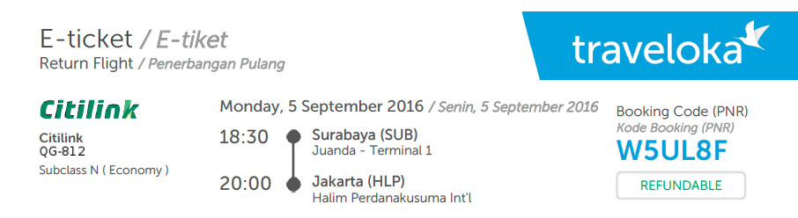


Normalisasi

Field | Type | Size | Description
pnr_code | VARCHAR | 10 | Primary Key (Booking Code)
air_code | VARCHAR | 10 | Foreign Key (Airline ID)
origin | VARCHAR | 50 | City of Departure
destination | VARCHAR | 50 | City of Arrival
travel_date | DATE | - | Departure Date
etd | TIME | - | Estimated Time of Departure
baggage | VARCHAR | 10 | Baggage Capacity (20 kg)

Database

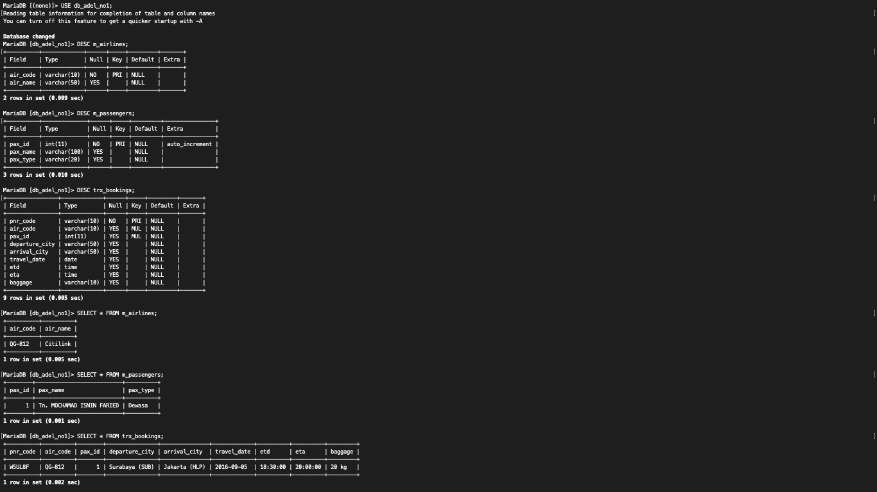

- Bukti transaksi

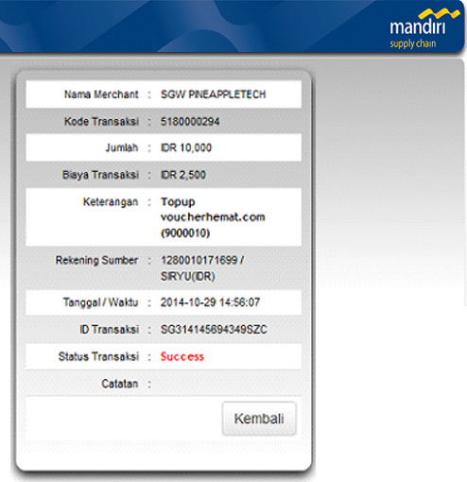

Normalisasi

Field | Type | Size | Description
payment_id | VARCHAR | 50 | Primary Key (Transaction ID)
ref_code | VARCHAR | 20 | Reference Number
v_id | INT | 11 | Foreign Key (Vendor ID)
amount | DECIMAL | 15,2 | Total Payment Amount
fee | DECIMAL | 10,2 | Admin Fee
datetime_trx | DATETIME | - | Transaction Timestamp
trx_status | VARCHAR | 20 | Transaction Status (Success)

Database

